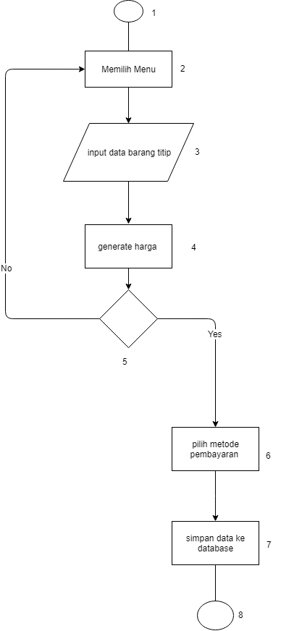 Method : menitip_barang() Method : melihat_barangTitip()

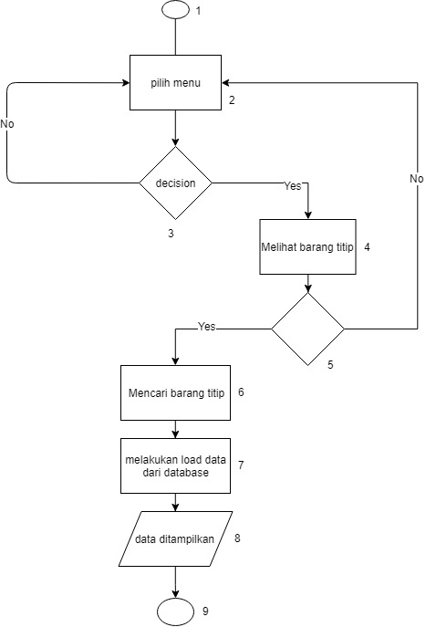

Cyclomatic complexity : 2 Cyclomatic complexity : 4

Path : path :

1-2-3-4-5-6-7-8 1-2-3-4-5-6-7-8-9

1-2-3-4-5-2-3-4-5-6-7-8 1-2-3-2-3-4-5-6-7-8-9

1-2-3-4-5-2-3-4-5-6-7-8-9

1-2-3-2-3-4-5-2-3-4-5-6-7-8-9

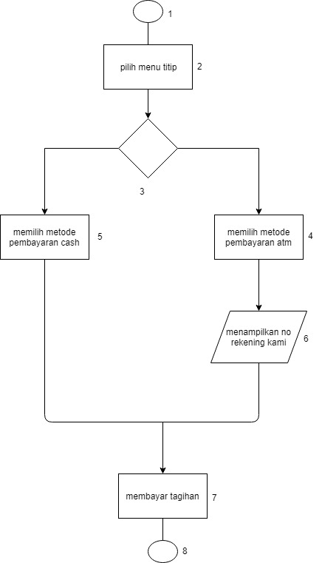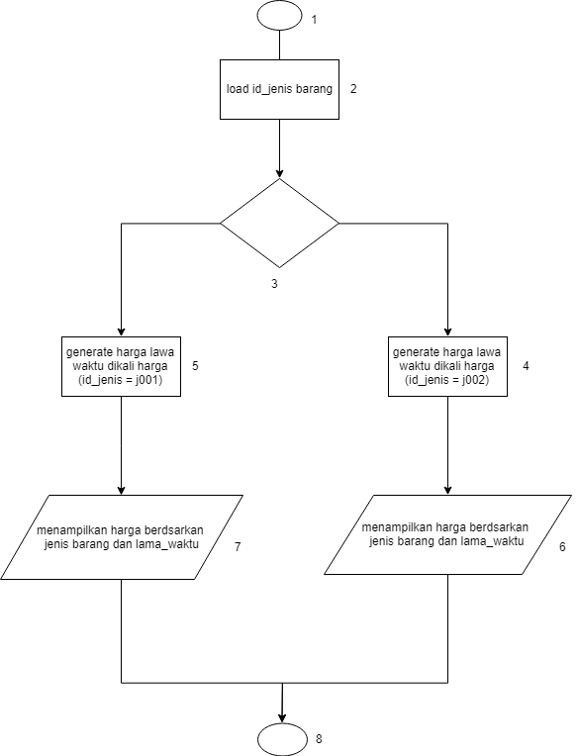method : show_harga() method : bayar_barang()

Cyclomatic complexity : 2 cyclomatic complexity : 2

Path : path :

1-2-3-4-6-8 1-2-3-4-6-7-8

1-2-3-5-7-8 1-2-3-5-7-8